Quick Guide - How to Record Videos using Panopto Capture for Students

Contents

Accessing Panopto Capture 2

Selecting a Microphone and Camera 3

Recording your screen 4

Recording 5

 **NOTE: This guide is 6 pages long and roughly 900 words, to keep this guide short and simple, additional information regarding settings, and all of the options available to you have been moved to a supplemental guide, this guide will walk you through the basics to get you recording.**

 **NOTE: If you are using a Mac, it is advisable to use a different web browser instead of Safari, as there can sometimes be issues with the web browser and Panopto.**

# Accessing Panopto Capture

**Panopto Capture** is browser based and **does not** require users to download any software – it allows users to record videos using their web browser and it is currently supported in Google Chrome, Firefox, and Edge.

Locate the Panopto submission point on the module page and click on it. It should be in the **Assessment and Feedback** section. You should be able to identify it by the **green** Panopto logo.

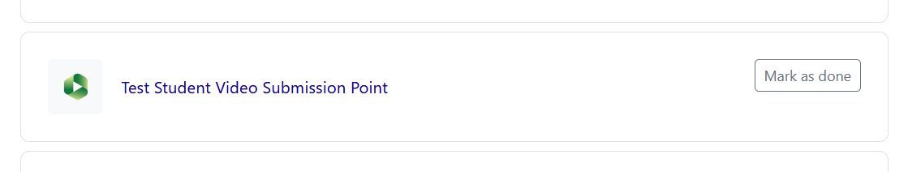

On the next page, you will see the **due date** and the **cut-off date** (last date that late submissions can be accepted). Click on the ‘**Add Panopto submission**’ button.

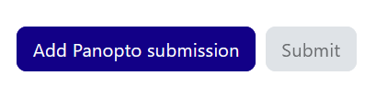

When the dialog loads, **click the ‘Record’ tab**, and scroll down the window a bit until you see the button ‘**Launch Capture**’ (Under ‘**Capture (Browser)**’)

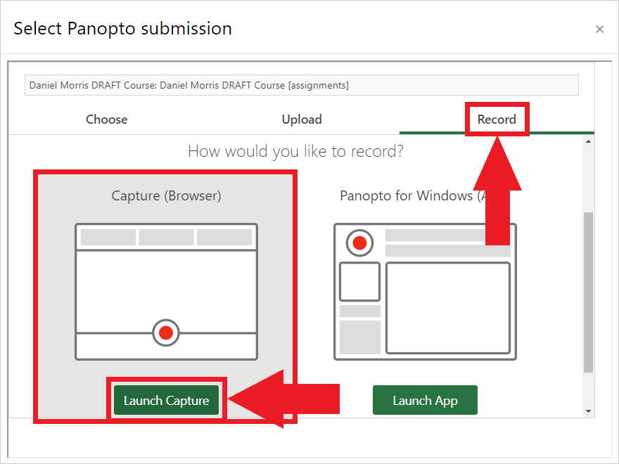

Once you have selected the Panopto Capture option, a new window will open which will allow users to record a video.

 **NOTE:** A pop-up dialogue boxes may appear asking for permission for your browser to use your **camera** and **microphone**. Click the ‘**Allow on every visit**’ option to grant access to these.

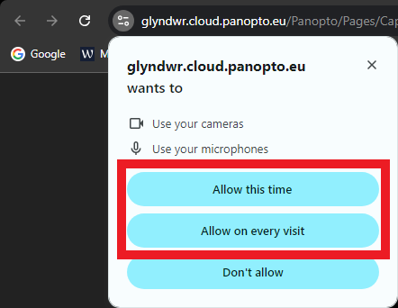

# Selecting a Microphone and Camera

Before starting to record a video, make sure that the appropriate microphone and camera are selected for the video.

To select a specific microphone, click on the **Microphone** icon at the top left of the screen.



After selecting the microphone icon, a list of all the available microphones will appear. Select the microphone that you wish to use.

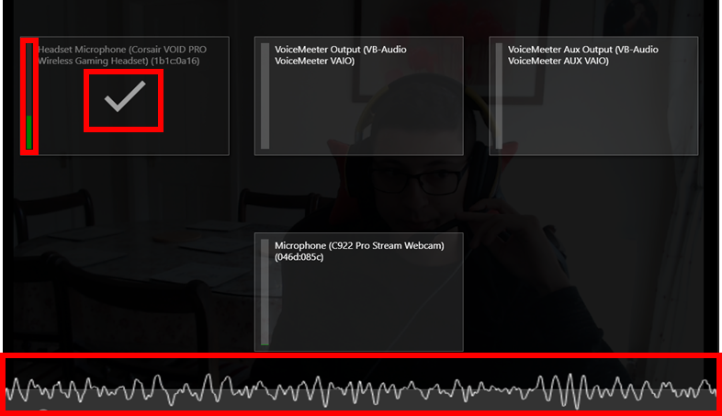

After selecting a microphone, click on the **Camera** icon at the top centre of the screen.



After selecting the camera icon, a list of all the available cameras will appear. You can either click on the active camera to turn it off or select a different camera if needed.

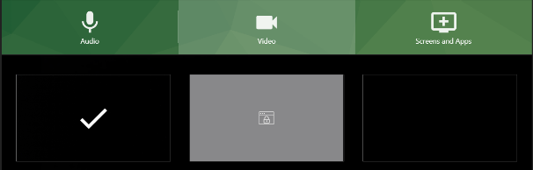 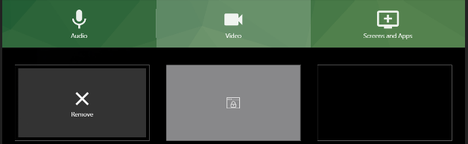

When hovering with your mouse over a video source, a set of buttons will appear for that source, you can click the ‘Cross’ icon to turn off your camera.

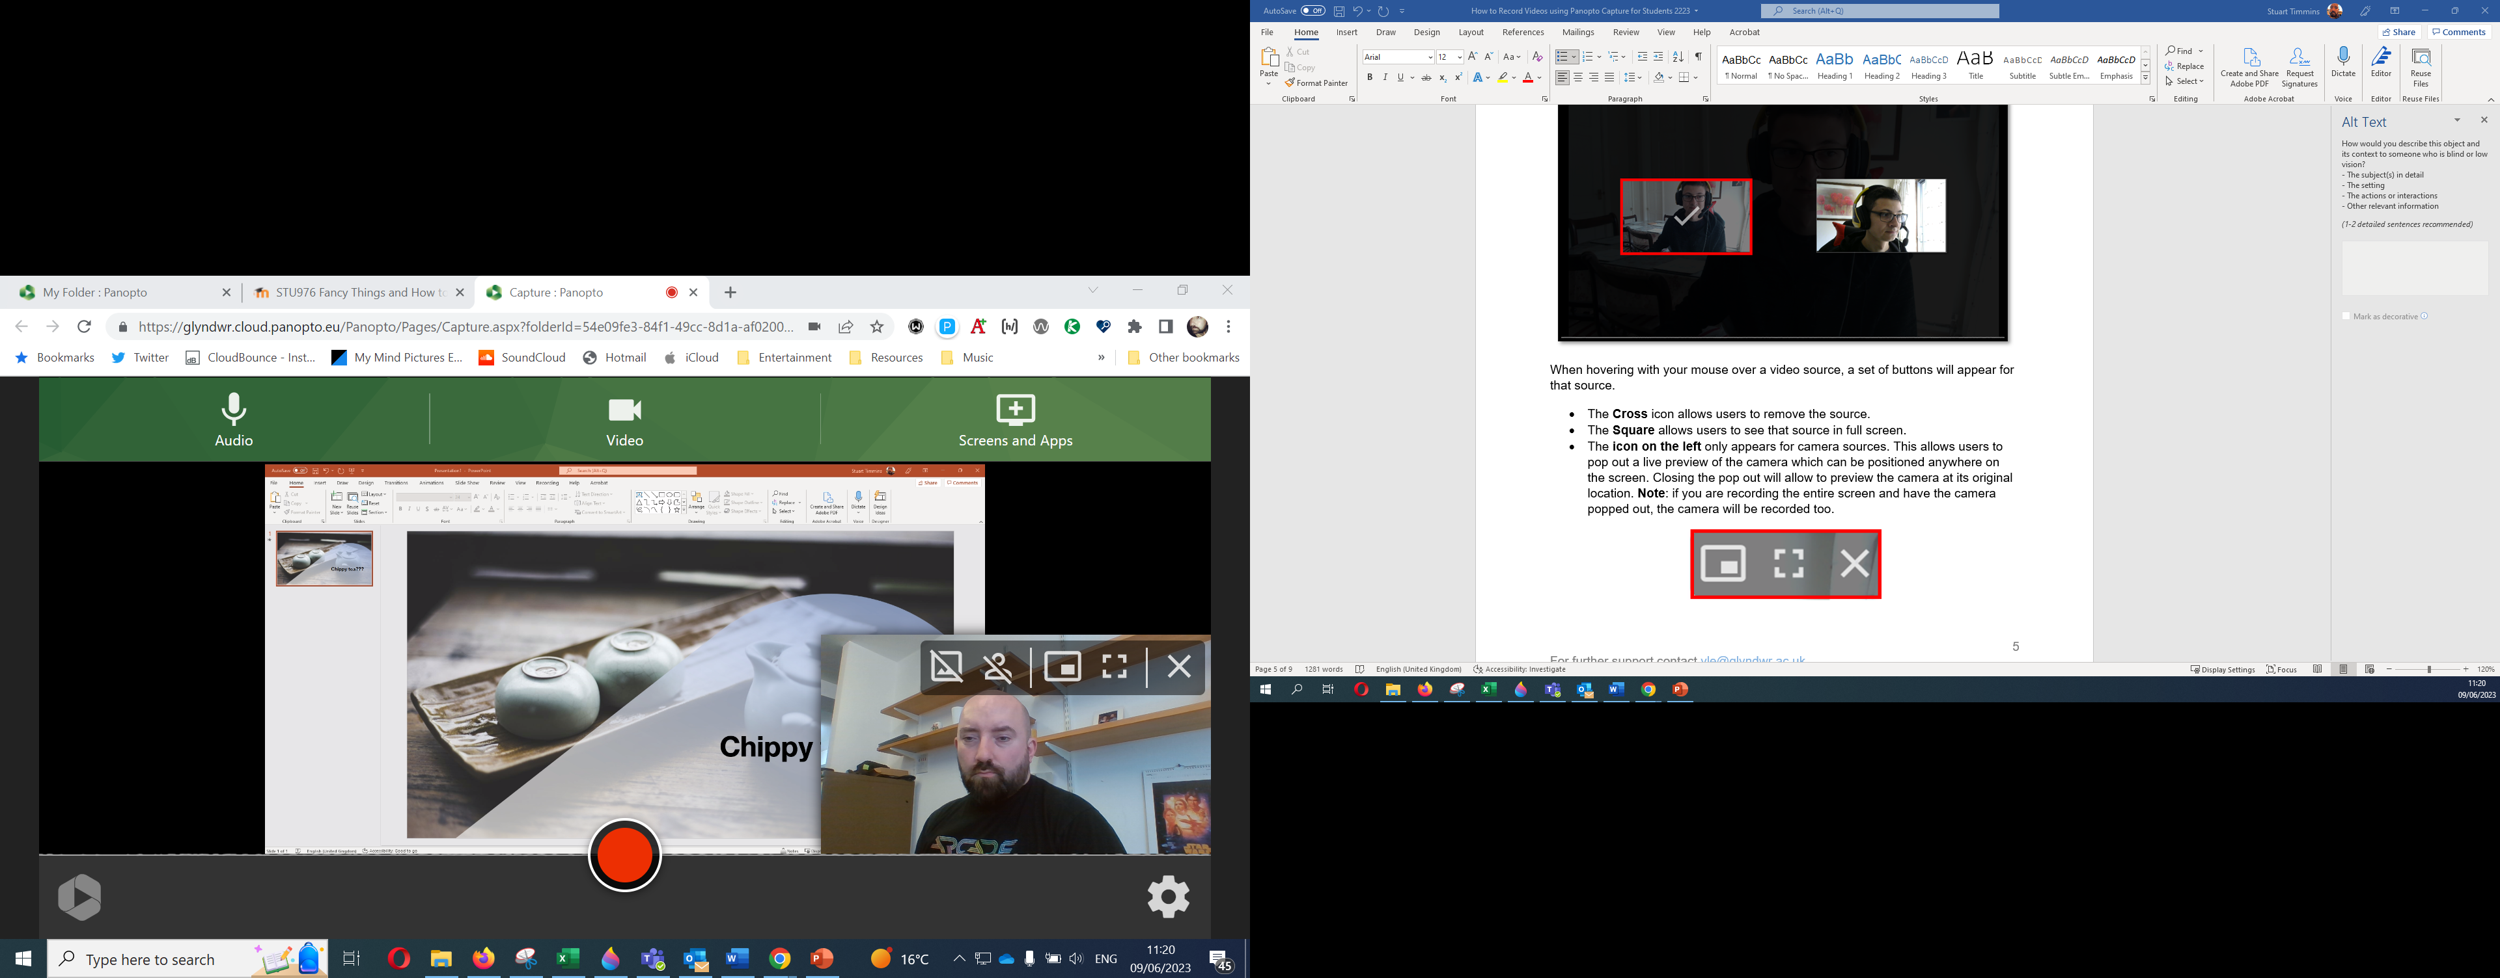

# Recording your screen

To record a secondary source, click on the **Monitor** icon (that should say ‘**Screens and Apps**’) located at the top right of the screen.



After clicking the Monitor icon, the Screen Share pop-up will appear. At the top of the pop-up there will be three different menus available:

1. **Entire Screen:** Will record every part of your screen.
2. **Application Window:** This will record one specific ‘window’/application.
3. **Chrome Tab:** This will record a specific tab on your web browser.

 **Hint:** **It is advisable to select ‘Entire Screen’ so that if you need to minimise your PowerPoint for example to jump to a webpage, Panopto will continue recording.**

 **NOTE: Make sure that you do not have anything personal open if you use ‘Entire screen’, since it will record everything that you display on your screen, remember though, only you will see the recording until you submit the video however.**

**If you choose the ‘Entire screen’ option**, make sure you **click on the screen displayed in the dialog first (as shown below) (you will still have to do this even if you have only one screen)**, otherwise **you will not be able to click the ‘Share’ button**, after picking a screen, tick ‘**Also share system audio**’ and then press ‘**Share**’.

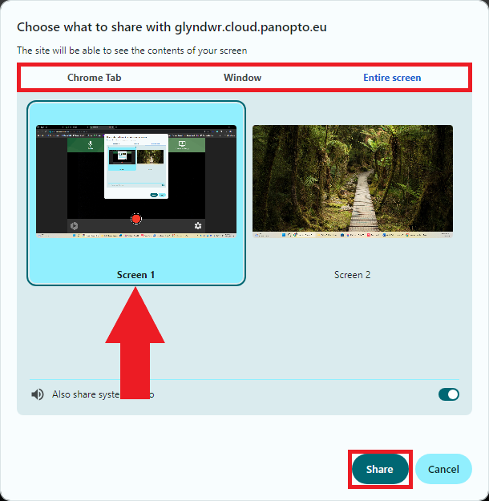

# Recording

Before recording, **click the settings cog in the bottom right corner of the screen** and **change the quality option from ‘SD’ to ‘HD’** and then **press the cross button** **at the bottom of the screen** as shown below.

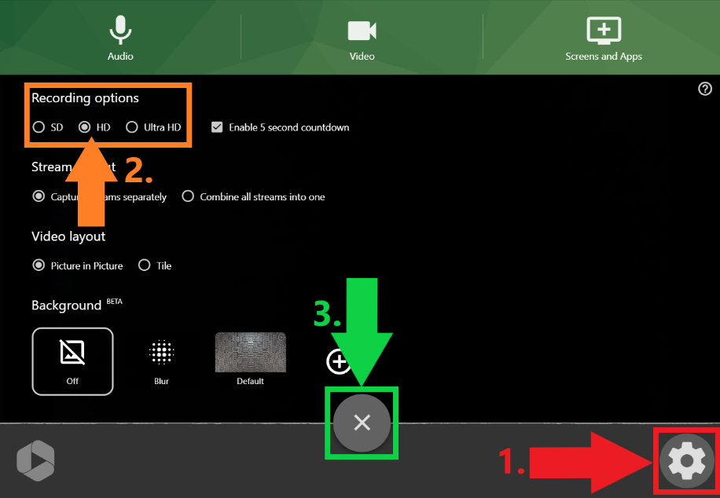

When you are ready to start recording a video, click on the **Red Circle** at the bottom centre of the screen.

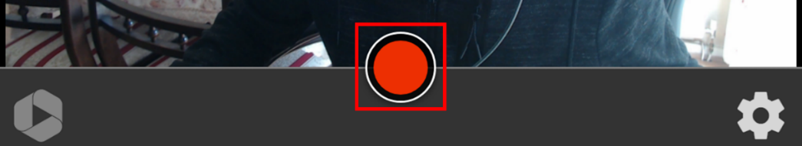

Once recording has started, a timer will be visible on the bottom right of the screen. Use the icons/tabs at the bottom of your screen to navigate between the program you are sharing and your Panopto window.

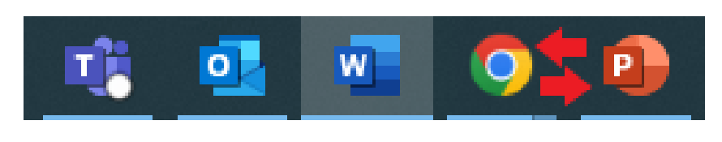

To stop recording, click the **Red Square** button which is in the same place as the Record button.

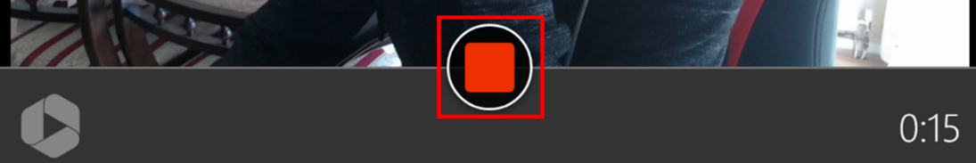

After clicking the stop recording button, a new window will appear.

A progress bar will start moving across the screen, wait until it says ‘**It’s safe to close your browser window**’ before exiting and returning to Moodle.

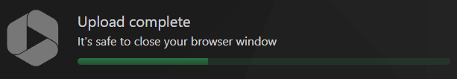

It is recommended to wait until the progress bar is fully green and says, ‘**Putting on the finishing touches**’, however, as long as it says, ‘**It’s safe to close your browser window**’, you can close the tab down or return to Moodle

If you would like to start again, you can click ‘**Redo**’, **which will delete the current recording and let you start again**, clicking ‘**Record New**’, will let you **keep the current video but create another recording** if needed.

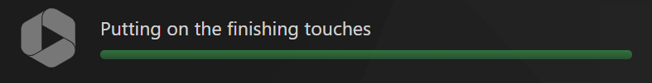

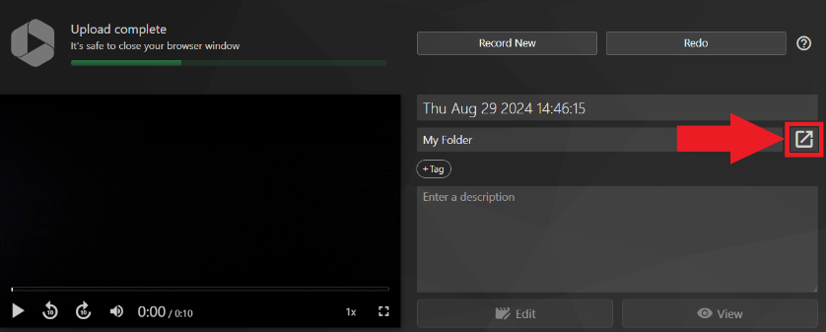

If you need to make any changes, click the ‘**View in folder**’ icon as shown below.



This will take you to the assignments folder where you can either edit the file or delete it as shown below.

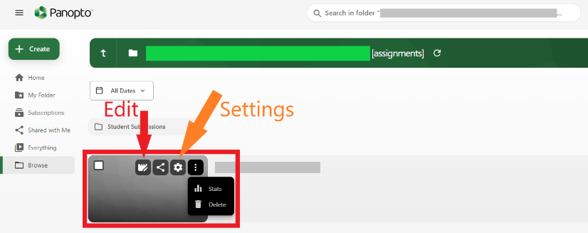

When you **either close the tabs or return to Moodle**, you should **see your recording appear in the upload section** **as shown below**, you can now click ‘**Insert**’ and then ‘**Submit**’ on the Moodle page.

